**Project Report**

# **User Profile and To-do List Application**

## **Introduction:**

This project is a web-based application that combines user authentication, profile management, and a to-do list feature. It is designed to provide a user-friendly interface for managing tasks while allowing users to view their profile information. The project aims to implement basic front-end development principles, utilizing HTML, CSS, and JavaScript for functionality and styling.

## **Features:**

1. **Login Page:**

* The Login Page validates user credentials for secure access.
* Successful login redirects to the Profile Page.

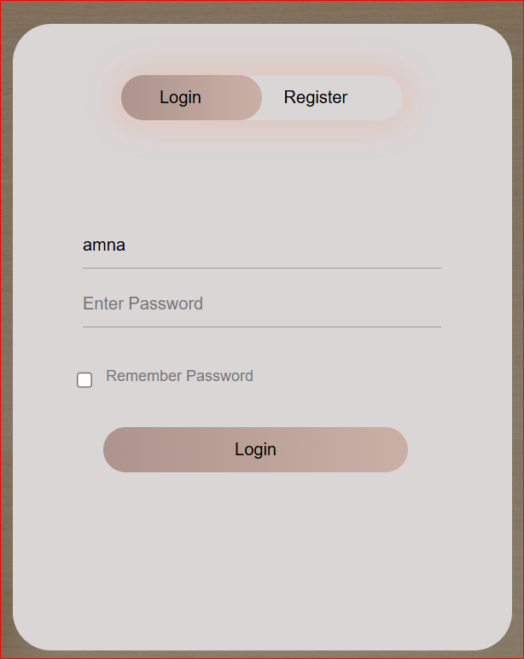

1. **User Profile Page:**
   * Displays username and email fetched from local storage.
   * Redirects users to the to-do list page.
   * Alerts users and redirects to the login page if no user is logged in.

1. **To-Do List Page:**
   * Allows users to add new tasks with descriptions.
   * Provides options to delete them.
   * Stores task data persistently in local storage.

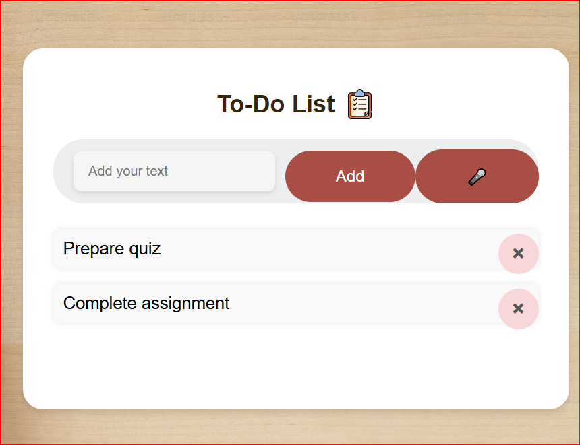

1. **Styling and Responsiveness:**
   * Clean and minimalistic design using CSS.
   * Ensures compatibility across desktops and mobile devices.
2. **Local Storage Integration:**
   * Stores user session and task data in the browser's local storage.
   * Ensures persistence between page reloads.

## **Code Breakdown:**

1. **HTML:**

* Separate pages for profile and to-do list.
* Semantic elements for accessibility and structure.

1. **CSS:**

* Focus on simplicity and readability.
* Custom styling for buttons, input fields, and containers.

1. **JavaScript:**

* Logic to handle user session and task operations.
* Functions for adding, removing, and displaying data dynamically.

## **Challenges and Solutions:**

1. **Challenge:** Maintaining user sessions across pages.
   * **Solution:** Used local storage to persist user data and retrieve it in each page script.
2. **Challenge:** Styling the application for mobile screens.
   * **Solution:** Implemented responsive design using CSS media queries.
3. **Challenge:** Ensuring data persistence for tasks.
   * **Solution:** Integrated task management with local Storage, updating it on every operation.

## **Improvements and Future Scope:**

1. **User Authentication:**
   * Add secure authentication with a back-end server instead of relying solely on local storage.
2. **Task Sharing:**
   * Implement functionality to share tasks with other users.
3. **Enhanced UI/UX:**
   * Integrate frameworks like Bootstrap or Materialize for advanced styling.
4. **Dark Mode:**
   * Add a theme toggle option for better user experience.

## **Conclusion:**

This project implements a basic user profile and a to-do list application, providing a responsive interface. By effectively utilizing front-end technologies, it achieves core functionality while leaving room for future advancements.